Problem definition:

[AirBnB](https://www.dataquest.io/m/139/www.airbnb.com) is a marketplace for short term rentals that allows you to list part or all of your living space for others to rent. You can rent everything from a room in an apartment to your entire house on AirBnB. Because most of the listings are on a short-term basis, AirBnB has grown to become a popular alternative to hotels. The company itself has grown from it's founding in 2008 to a 30 billion dollar [valuation in 2016](http://www.bloomberg.com/news/articles/2016-08-05/airbnb-files-to-raise-850-million-at-30-billion-valuation) and is currently worth more than any hotel chain in the world.

One challenge that hosts looking to rent their living space face is determining the optimal nightly rent price. In many areas, renters are presented with a good selection of listings and can filter on criteria like price, number of bedrooms, room type and more. Since AirBnB is a marketplace, the amount a host can charge on a nightly basis is closely linked to the dynamics of the marketplace. Here's a screenshot of the search experience on AirBnB:

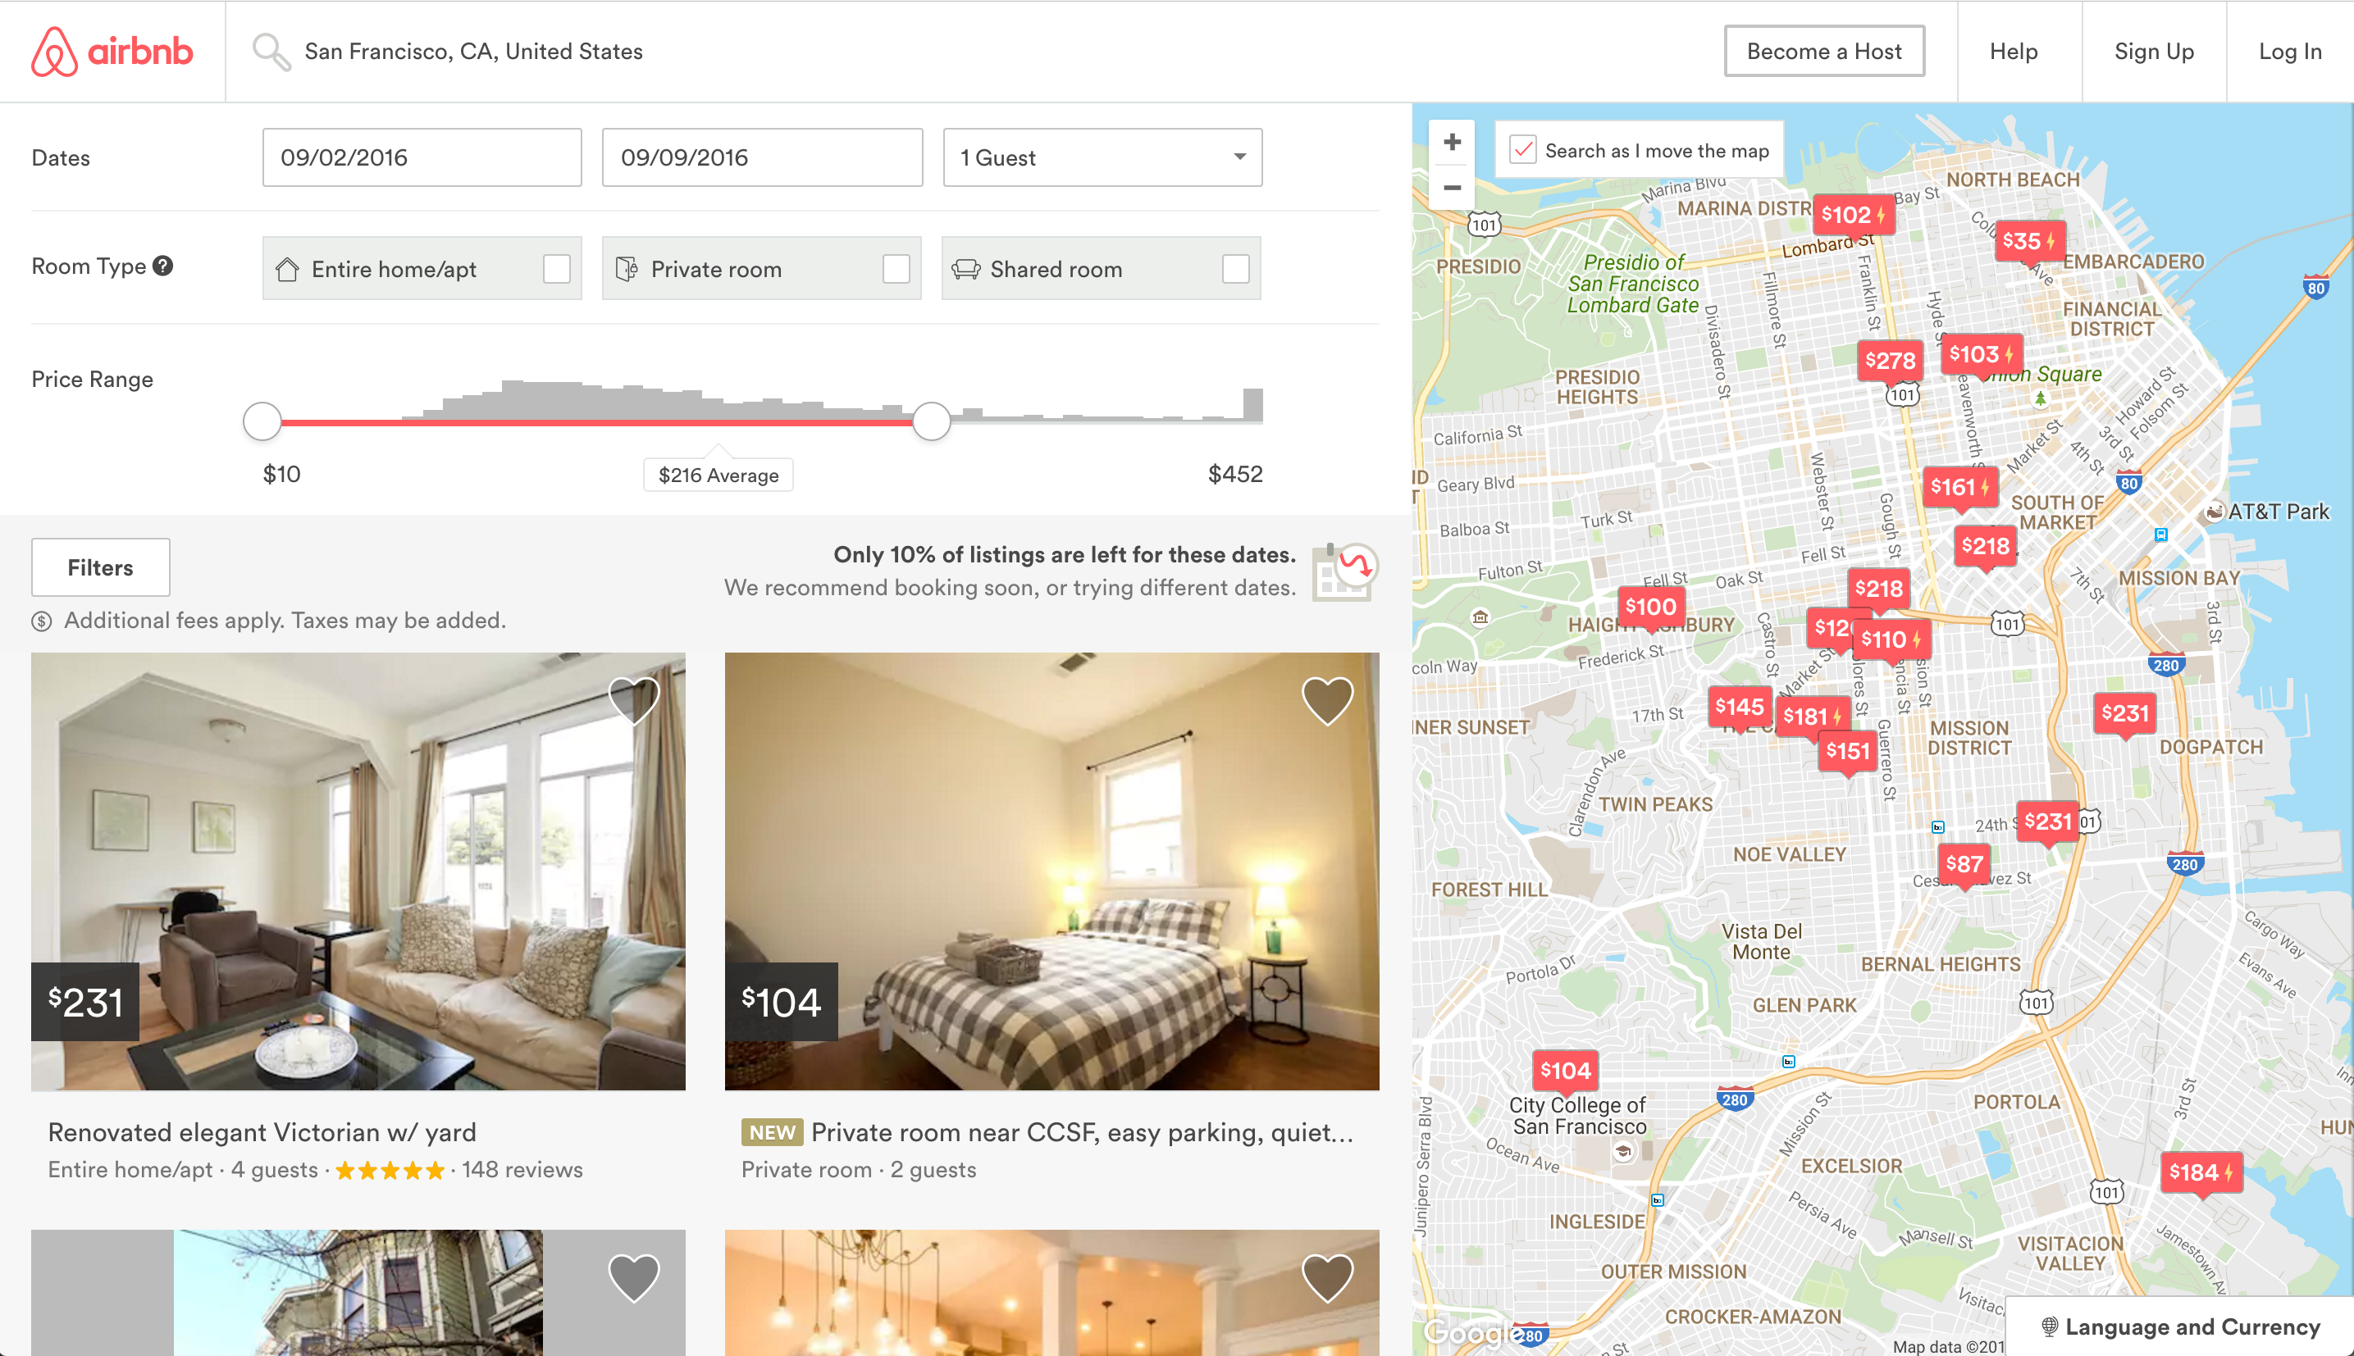

As a host, if we try to charge above market price for a living space we'd like to rent, then renters will select more affordable alternatives which are similar to ours.. If we set our nightly rent price too low, we'll miss out on potential revenue.

One strategy we could use is to:

* find a few listings that are similar to ours,
* average the listed price for the ones most similar to ours,
* set our listing price to this calculated average price.

The process of discovering patterns in existing data to make a prediction is called **machine learning**. In our case, we want to use data on local listings to predict the optimal price for us to set. In this mission, we'll explore a specific machine learning technique called **k-nearest neighbors**, which mirrors the strategy we just described. Before we dive further into machine learning and k-nearest neighbors, let's get familiar with the dataset we'll be working with.